Audiometric (Hearing) Tests

Onsite in a Mobile Unit or at an IOH Clinic
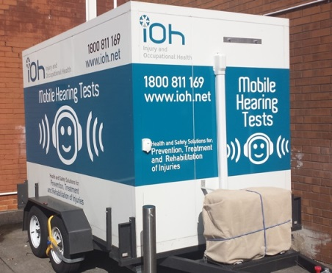
- Reference and monitoring hearing tests meeting AS/NZS1269.4:2014 Standard.
- Flexible options, with testing available in our clinics and onsite in mobile hearing units.
- Mobile units are fitted with sound proofed booths to ensure the environment is quiet.
- WHS legislation requires workers who frequently wear hearing protection to be tested at least every two years.
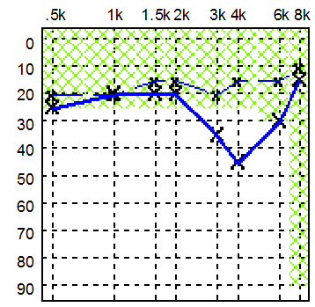
The IOH technician will identify loss patterns and shifts in hearing threshold from previous tests that can be an early warning sign to take action.
Testing alone is not a preventive measure, but it is an important mechanism for managing risks from noise exposure in a workplace.
Call your local IOH office to discuss your needs and we will develop a solution that fits.

